Autoresonance threshold of electron in DC electric field with circular emw
2.1 Field equations
To analyze interaction between electron and E.M wave, we consider an E.M wave propagating along uniform magnetic field whose phase velocity $v_{T} = ω/k$, where ω is the angular frequency and k is the wavenumber. The uniform background magnetic field is B₀ = B₀ẑ. The wave's magnetic field perturbation B̃ is characterized by the dimensionless parameter $κ$ ≡ |B̃|/B₀, such that the total magnetic field becomes B = B₀ẑ + B̃. The system includes a static electric field E₀ = E₀ẑ, with the total electric field given by E = E₀ẑ + Ẽ, where Ẽ represents the electric field components of E.M wave:
$$\begin{aligned}\tilde{E}= E_{w} \left[\hat{x}cos\left(kz - ωt\right)+g ŷ sin\left(kz - ωt\right)\right]\#\left( SEQ equation 1\right)\end{aligned}$$
Here, $E_{w}$ is the electric field amplitude of E.M wave, and the polarization satisfies the left-hand circular polarization (LCP) condition when $g$ = 1, and right-hand circular polarization (RCP) condition when $g$ = -1.
Faraday’s law requires the associated magnetic field to be
$$\begin{aligned}\tilde{B}=\frac{k}{ω}\hat{z}×\tilde{E}=κB_{0}\left[-g \hat{x}\sin\left(kz-ωt\right)+\hat{y}\cos\left(kz-ωt\right)\right]\#\left( SEQ equation 2\right)\end{aligned}$$
Here $κB_{0}=B_{w}=\frac{k}{ω}E_{w}$.
2.2 Transformation to the wave frame
In wave frame, which denotes as prime and moves at constant velocity $v_{T} =ω/k$ with respect to the lab frame, the fields are
$$\begin{aligned}E_{∥}^{'}=E_{∥}\#\left( SEQ equation 3\right)\end{aligned}$$
$$\begin{aligned}B_{∥}^{'}=B_{∥}\#\left( SEQ equation 4\right)\end{aligned}$$
$$\begin{aligned}E_{⊥}^{'}=γ_{T}{\left(E+v_{T}×B\right)}_{⊥}\#\left( SEQ equation 5\right)\end{aligned} \\ \begin{aligned}B_{⊥}^{'}=γ_{T}{\left(B-\frac{1}{c^{2}}v_{T}×E\right)}_{⊥}\#\left( SEQ equation 6\right)\end{aligned}$$
Where $γ_{T}=1/\sqrt{1-{\left(\frac{v_{T}}{c}\right)}^{2}}$. Substituting the wave fields Eq. $\left(1\right)$, Eq. $\left(2\right)$ into Eq.$\left(5\right)$, Eq. $\left(6\right)$ gives $E_{⊥}^{'}=0$ and $B_{⊥}^{'}=\frac{B_{⊥}}{γ_{T}}$.
Since $\{k,\frac{iω}{c}\}$ and {x, ict} are relativistic four-vectors, we have $$\begin{aligned}kz-ωt=kγ_{T}\left(z^{'}+v_{T}t^{'}\right)-ωγ_{T}\left(t^{'}+\frac{v_{T}z^{'}}{c^{2}}\right)=k^{'}z^{'}\#\left( SEQ equation 7\right)\end{aligned}$$
Here $k^{'}=k/γ_{T}$ and $z'$ are the wavenumber and position in the wave frame. The magnetic field of E.M wave is
$$\begin{aligned}B_{⊥}^{'}=B_{⊥}^{'}\left( -g \hat{x}\sin\left(k^{'}z^{'}\right)+\hat{y}\cos\left(k^{'}z^{'}\right)\right)\#\left( SEQ equation 8\right)\end{aligned}$$
The motion equation of the charge particle in the prime frame is
$$\begin{aligned}\frac{d}{dt^{'}}\left(γ^{'}β^{'}\right)=\frac{q}{m_{0}}\left(\frac{E_{0}}{c}\hat{z}+β^{'}×B^{'}\right)\#\left( SEQ equation 9\right)\end{aligned}$$
Where $γ^{'}=1/\sqrt{1-{β' }^{2}}$ , m₀ is the rest mass of electron and q is the electron charge with q = -e. Note that $γ$,$γ_{T}$, and $γ'$ differ and should not be confused with each other. The derivation of energy $γ'$ to t’ and the motion equation in each direction should be
$$\begin{aligned}\frac{dγ^{'}}{dt^{'}}=\frac{qE_{0}\hat{z}⋅β_{z}^{'}}{m_{0}c}\#\left( SEQ equation 10\right)\end{aligned}$$
$$\begin{aligned}\frac{d}{dt^{'}}\left(γ^{'}β_{z}^{'}\right)=Ω\left(\frac{E_{0}}{cB_{0}}\hat{z}+β_{⊥}^{'}×\frac{B_{⊥}^{'}}{B_{0}}\right)\#\left( SEQ equation 11\right)\end{aligned}$$
$$\begin{aligned}\frac{d}{dt^{'}}\left(γ^{'}β_{⊥}^{'}\right)=Ω\left(β_{⊥}^{'}×\hat{z}+β_{z}^{'}\hat{z}×\frac{B_{⊥}^{'}}{B_{0}}\right)\#\left( SEQ equation 12\right)\end{aligned}$$
Here $Ω$ is the nonrelativistic electron cyclotron frequency in the lab frame with $Ω<0$. Introduce
$$\begin{aligned}ξ_{z}=1+αγ^{'}β_{z}^{'}\#\left( SEQ equation 13\right)\end{aligned}$$
Here $α= \frac{gω}{Ωγ_{T}}n,n=ck/ω.$
$$\begin{aligned}ξ_{⊥}=1+αγ^{'}β_{⊥}^{'}\#\left( SEQ equation 14\right)\end{aligned}$$
According to Eq. $\left(10\right)$ and Eq. $\left(12\right)$, we have
$$\begin{aligned}\frac{dβ_{⊥}^{'}}{dτ}=\left(β_{⊥}^{'}×\hat{z}+β_{z}^{'}\left(\hat{z}×\frac{B_{⊥}^{'}}{B_{0}}\right)\right)-\frac{E_{0}\hat{z}⋅β_{z}^{'}}{cB_{0}}β_{⊥}^{'}\#\left( SEQ equation 15\right)\end{aligned}$$
Where $τ=t^{'}Ω^{'}$ , $Ω^{'}=\frac{Ω}{γ^{'}}.$Consider $κ^{'}=\left|\frac{B_{⊥}^{'}}{B_{0}}\right|=\frac{κ}{γ_{T}}$ and ignore the last term when $\frac{E_{0}}{cB_{0}}≪1$
$$\hat{z}×κ^{'}\left[-g \hat{x}\sin\left(k^{'}z^{'}\right)+\hat{y}\cos\left(k^{'}z^{'}\right)\right]= κ^{'}\left[-g\hat{y}\sin\left(k^{'}z^{'}\right)-\hat{x}\cos\left(k^{'}z^{'}\right)\right]$$
$$\begin{aligned}=-κ^{'}\left[g\hat{y}\sin\left(k^{'}z^{'}\right)+\hat{x}\cos\left(k^{'}z^{'}\right)\right]\#\left( SEQ equation 16\right)\end{aligned}$$
$$\begin{aligned}β_{⊥}^{'}=β_{x}^{'}\hat{x}+β_{y}^{'}\hat{y}\#\left( SEQ equation 17\right)\end{aligned}$$
$$β_{⊥}^{'}×\hat{z}= -\hat{y}β_{x}^{'}+\hat{x}β_{y}^{'}$$
$$\frac{dβ_{x}^{'}}{dτ}=β_{y}^{'}-{β_{z}^{'}κ}^{'} \cos\left(k^{'}z^{'}\right)$$
$$\frac{dβ_{y}^{'}}{dτ}={-β}_{x}^{'}-{β_{z}^{'}κ}^{'} g\sin\left(k^{'}z^{'}\right)$$
Now define $β_{⊥}^{'}=β_{x}^{'}+iβ_{y}^{'}$
$$\frac{dβ_{⊥}^{'}}{dτ}=β_{y}^{'}-iβ_{x}^{'}-β_{z}^{'}κ^{'}\left(\cos\left(θ\right)+igsin\left(θ\right)\right)$$
$$= -iβ_{⊥}^{'}-β_{z}^{'}κ^{'}exp⁡(igθ)$$
Here, $θ=k^{'}z^{'}$. To cancel the $θ$ angle, define $β_{⊥}^{'}=Vexp\left(igθ\right)$
Than
$$\begin{aligned}\frac{dV}{dτ}+i\left(g\frac{dθ}{dτ}+1\right)V=-β_{z}^{'}κ^{'}\#\left( SEQ equation 18\right)\end{aligned}$$
$$\frac{dθ}{dτ}=\frac{dθ}{dt^{'}}\frac{dt^{'}}{dτ}=\frac{1}{Ω^{'}}k^{'}β_{z}^{'}c=\frac{ωn}{γ_{T}Ω}γ^{'}β_{z}^{'}=αγ^{'}β_{z}^{'}$$
According to eq. $\left(13\right)$, we have
$$\begin{aligned}g\frac{dθ}{dτ}+1=ξ_{z}\#\left( SEQ equation 19\right)\end{aligned}$$
According to Eq. $\left(11\right)$ , Eq. $\left(12\right)$, we have
$$\begin{aligned}\frac{dξ_{z}}{dt^{'}}=αΩ\left(\frac{E_{0}}{cB_{0}}\hat{z}+\frac{ξ_{⊥}-1}{αγ'}×\frac{B_{⊥}^{'}}{B_{0}}\right)⋅\hat{z}\#\left( SEQ equation 20\right)\end{aligned}$$
If we consider the EMW to be small, we only include the first term of the equation, than
$$\frac{dξ_{z}}{dτ}=αγ^{'}\frac{E_{0}}{cB_{0}}=\frac{ςE_{0}}{cB_{0}}=a$$
Near the resonance crossing we used
$$ξ_{z}=aτ$$
And $β_{z}^{'}=β_{zr}^{'}$
Therefore,
$$\frac{dV}{dτ}+iaτV=-β_{z}^{'}κ^{'}$$
According to eq.$\left(11\right)$, when $\frac{E_{0}}{cB_{0}}≪1$ and ignore EMW, we have
$$\frac{dβ_{z}^{'}}{dτ}=\frac{E_{0}}{cB_{0}}$$
$$β_{z}^{'}=β_{zr}^{'}+τA$$
Where $A=\frac{E_{0}}{cB_{0}}$
$$\frac{dV}{dτ}+iaτV=-\left(β_{zr}^{'}+Aτ\right)κ^{'}$$
$$V\left(τ\right)=-κ^{'}e^{-\frac{iaτ^{2}}{2}}\int_{τ_{1}}^{τ}{\left(β_{zr}^{'}+As\right)e^{\frac{ias^{2}}{2}}ds}$$
$$V=V_{0}+V_{1}$$
$$V_{0} =-κ^{'}β_{zr}^{'}e^{-\frac{iaτ^{2}}{2}}\int_{τ_{1}}^{τ}{e^{\frac{ias^{2}}{2}}ds}$$
$$V_{1}=-Aκ^{'}β_{zr}^{'}e^{-\frac{iaτ^{2}}{2}}\int_{τ_{1}}^{τ}{se^{\frac{ias^{2}}{2}}ds}$$
Consider $τ_{1}= -τ$ than
$$\int_{-τ}^{τ}{e^{\frac{ias^{2}}{2}}ds}=\sqrt{\frac{2π}{a}}e^{\frac{iπ}{4}}erf⁡(e^{-\frac{iπ}{4}}τ\sqrt{\frac{2π}{a}} )$$
As $τ≫1$, than
$$\operatorname{erf}\left(e^{-\frac{iπ}{4}}τ\sqrt{\frac{2π}{a}} \right)≈1$$
$$V_{0} =-κ^{'}β_{zr}^{'}\sqrt{\frac{2π}{a}}e^{-\frac{iaτ^{2}}{2}+\frac{iπ}{4}}$$
$V_{1}=0$due to odd equation in the integral
Now, consider the EMW in eq.$\left(11\right)$,it can be written as
$$\frac{dβ_{z}^{'}}{dτ}=\frac{E_{0}}{cB_{0}}+β_{⊥}^{'}×k^{'}\left[-g \hat{x}\sin\left(θ\right)+\hat{y}\cos\left(θ\right)\right]$$

$$β_{⊥}^{'}×k^{'}\left[-g \hat{x}\sin\left(θ\right)+\hat{y}\cos\left(θ\right)\right]$$
$$=k^{'}\left(β_{x}^{'}\hat{x}+β_{y}^{'}\hat{y} \right)×\left[-g \hat{x}\sin\left(θ\right)+\hat{y}\cos\left(θ\right)\right]$$
$$=κ^{'}\left(β_{x}^{'}\cos\left(θ\right)+β_{y}^{'}gsin\left(θ\right)\right)\hat{z}$$
Also , we have
$$β_{⊥}^{'}=Vexp\left(igθ\right)$$
Than
$$V=β_{⊥}^{'}exp\left(-igθ\right)$$
$$Re\left(V\right)=β_{x}^{'}\cos\left(θ\right)+β_{y}^{'}gsin\left(θ\right)$$

$$\frac{dβ_{z}^{'}}{dτ}=\frac{E_{0}}{cB_{0}}+κ^{'}Re\left(V\right)$$
$$f_{E_{0}}=\frac{E_{0}}{cB_{0}}$$
$$f_{wave}=κ^{'}Re\left(V\right)$$
If the electron is trapped, it must have
$$f_{wave}>f_{E_{0}}$$
Than
$$κ^{'}Re\left(V\right)>f_{E0}$$
$$\sqrt{\frac{2π}{a}}{κ_{c}^{'}}^{2}\left|β_{zr}^{'}\right|=\frac{E_{0}}{cB_{0}}$$
In the resonant condition
$$0=1+αγ^{'}β_{zr}^{'}$$
$$\left|β_{zr}^{'}\right|=\frac{1}{αγ^{'}}$$
$${κ_{c}^{'}}^{2}={\left(\frac{1}{2π}\right)}^{1/2}a^{\frac{3}{2}}$$
Here $a=αγ^{'}\frac{E_{0}}{cB_{0}}=\frac{ςE_{0}}{cB_{0}}$
So
$$κ_{c}^{'}={\left(\frac{1}{2π}\right)}^{1/4}{\left(\frac{ςE_{0}}{cB_{0}}\right)}^{\frac{3}{4}}=0.6316{\left(\frac{ςE_{0}}{cB_{0}}\right)}^{\frac{3}{4}}$$

Method2 : Simplify to a single parameter nonlinear Schrodinger-type equation
$$\begin{aligned}\frac{dγ^{'}}{dt^{'}}=\frac{qE_{0}\hat{z}⋅β_{z}^{'}}{m_{0}c}\#\left( SEQ equation 21\right)\end{aligned}$$
$$\begin{aligned}\frac{d}{dt^{'}}\left(γ^{'}β_{z}^{'}\right)=Ω\left(\frac{E_{0}}{cB_{0}}\hat{z}+β_{⊥}^{'}×\frac{B_{⊥}^{'}}{B_{0}}\right)\#\left( SEQ equation 22\right)\end{aligned}$$
$$\begin{aligned}\frac{d}{dt^{'}}\left(γ^{'}β_{⊥}^{'}\right)=Ω\left(β_{⊥}^{'}×\hat{z}+β_{z}^{'}\hat{z}×\frac{B_{⊥}^{'}}{B_{0}}\right)\#\left( SEQ equation 23\right)\end{aligned}$$
Here $Ω$ is the nonrelativistic electron cyclotron frequency in the lab frame with $Ω<0$. Introduce
$$\begin{aligned}x=1+αγ^{'}β_{z}^{'}\#\left( SEQ equation 24\right)\end{aligned}$$
Where $α= \frac{gω}{Ωγ_{T}}n,n=ck/ω$
Consider $\frac{E_{0}}{cB_{0}}=ϵ$, $r=αγ^{'}β_{⊥}^{'}$, using dimensionless time with define
$$τ=\frac{Ω}{γ^{'}}t'$$
Also, consider the rotation angle of electron as $θ$ and the angle of magnetic field as $θ_{B}$,define $δ= θ_{B}-θ$ ,$κ^{'}=B_{⊥}^{'}/B_{0}$
According to eq. $\left(22\right)$ and eq.$\left(23\right)$ , we have
$$\dot{x}=αγ^{'}ϵ+rκ^{'}sinδ$$
$$\dot{r}=-κ^{'}\left(x-1\right)sinδ$$
Consider $θ=arctan⁡(\frac{v}{u})$, $θ_{B}=k^{'}z^{'}$, where $u=rcosθ$ and $v=rsinθ$
We have
$${\dot{θ}}_{B}=k^{'}β_{z}^{'}c \frac{dt^{'}}{dτ}=x-1$$
And
$$\dot{θ}=-1+\frac{κ^{'}\left(x-1\right)cosδ}{r}$$
Finally
$$\dot{δ}=x-\frac{κ^{'}\left(x-1\right)cosδ}{r}$$
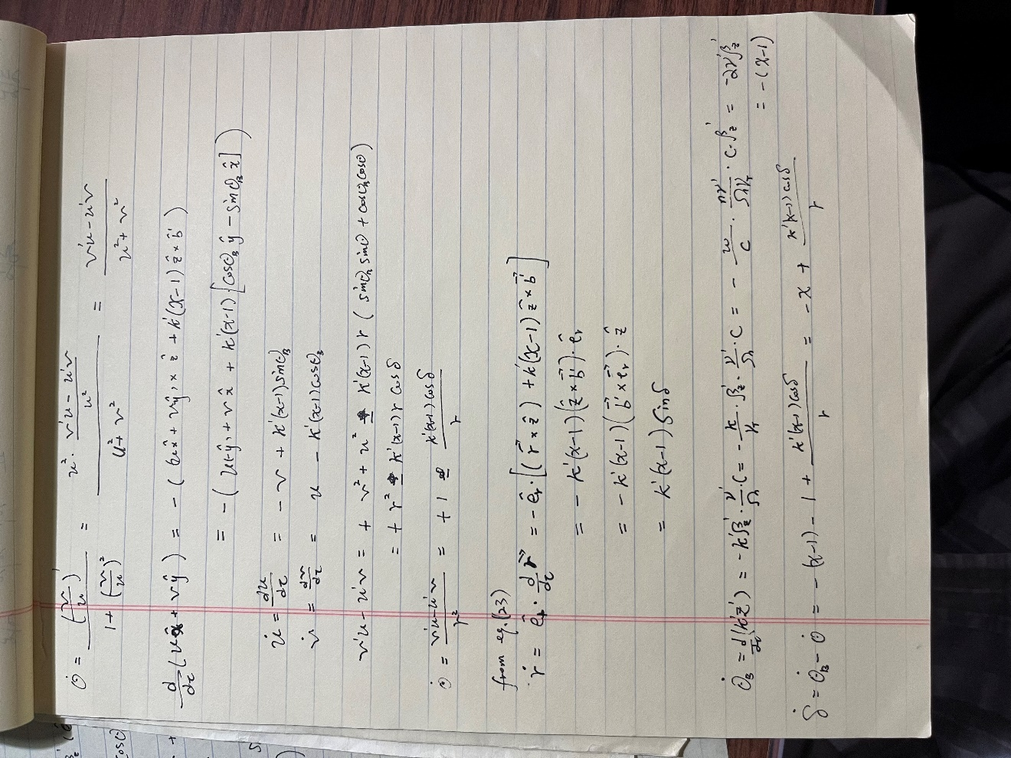
Combine all these equations gives:
$$i\frac{∂z}{∂τ}-\left(\frac{{\left|z\right|}^{2}}{2}-Λ\right)Z=k^{'}$$
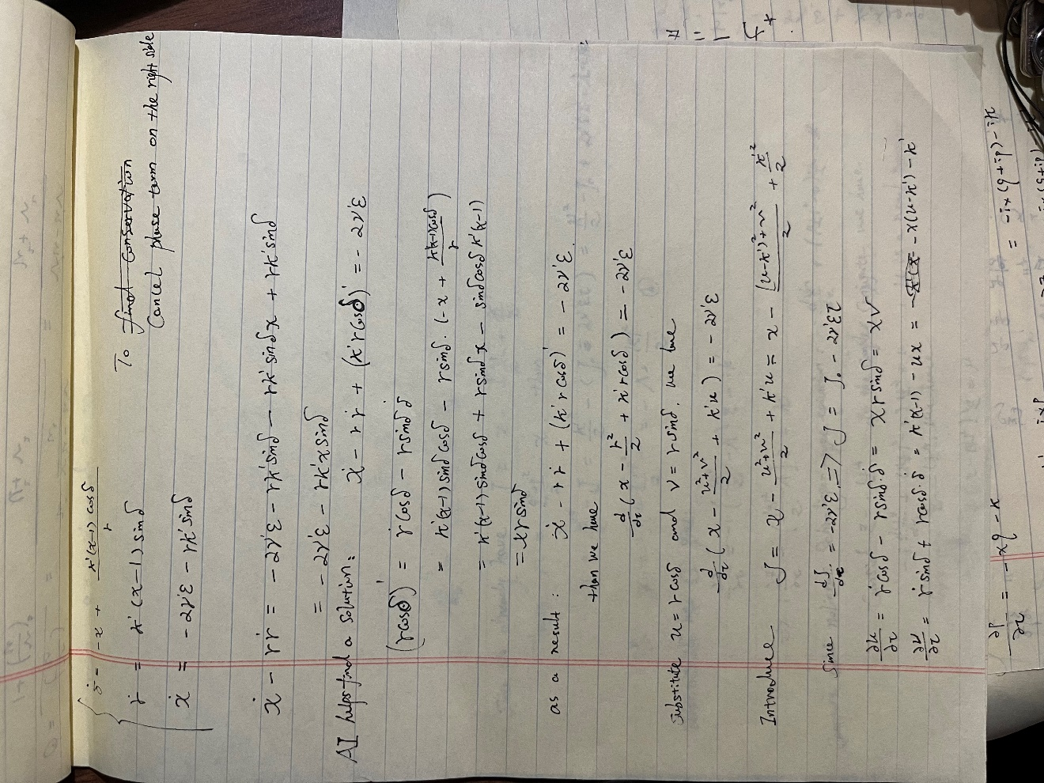
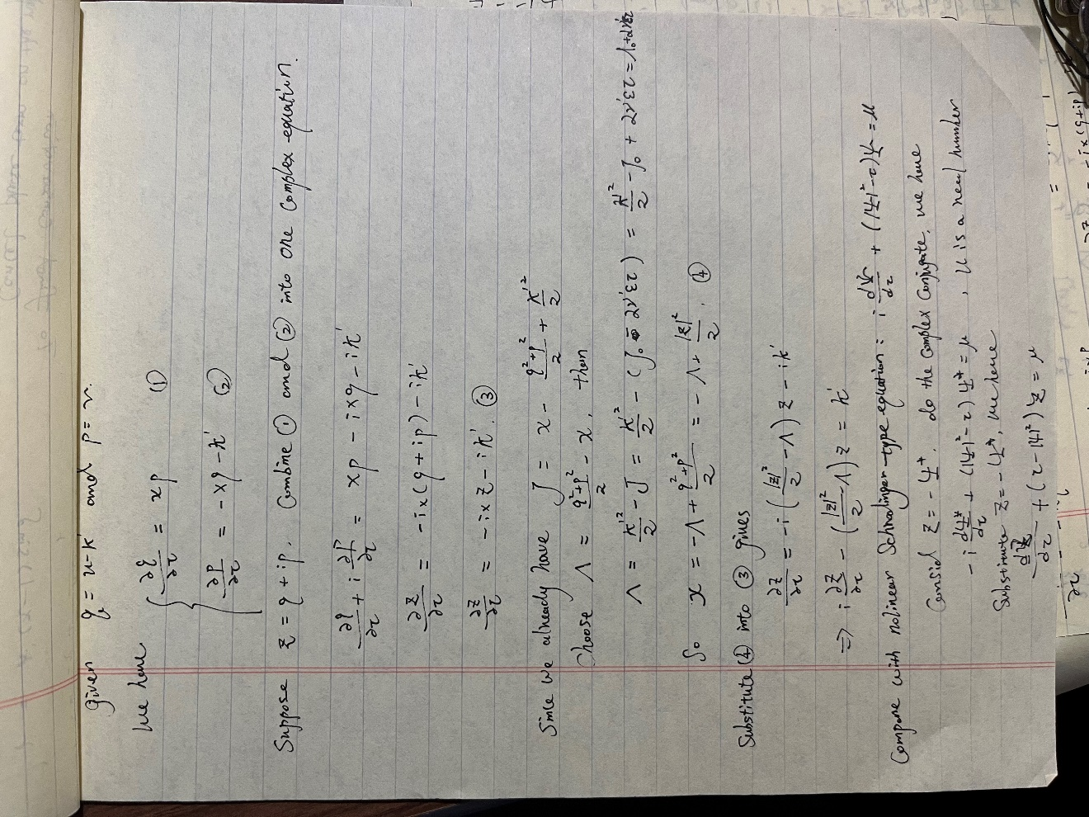
To change the equation to the form
$$i\frac{∂Z}{∂T}+\left(\frac{{\left|Z\right|}^{2}}{2}-Λ\right)Z=k^{'}$$

Which has been well studied
